**Overview of "An index finger exoskeleton with series elastic actuation for rehabilitation: Design, control and performance characterization"**

**Research Motivation:**

The paper addresses the critical need for effective rehabilitation solutions for individuals with upper extremity disabilities. With over 19.9 million people in the US alone experiencing limitations in hand function, the development of advanced robotic devices for hand rehabilitation is essential. The study aims to bridge the gap in existing hand exoskeleton technology by introducing a novel index finger exoskeleton with series elastic actuation, focusing on precise force and torque control to enhance rehabilitation outcomes.

**Innovation Points:**

The key innovation of the study lies in the incorporation of series elastic actuation (SEA) in the design of the index finger exoskeleton. This innovative approach enables bidirectional torque control, a feature lacking in many existing hand exoskeletons. By implementing SEA, the exoskeleton offers high back drivability and low reflected inertia, essential for providing accurate force and torque assistance during rehabilitation. The study also introduces controllers for exoskeleton and finger joint torque, enhancing the device's ability to interact seamlessly with the user's hand.

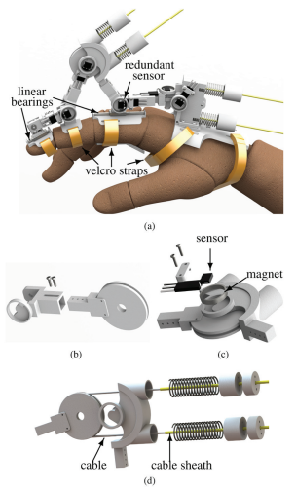

**Fig. 4.** CAD model of the designed index finger exoskeleton prototype. (a) Overall design of the exoskeleton, (b) adjustable link length assembly, (c) angle sensor and ring magnet assembly for joint angle sensing, and (d) Bowden-cable-based compression spring SEA design.

**Design Methods:**

The design methodology of the index finger exoskeleton involves careful consideration of the mechanical structure to minimize reaction forces at the finger joints while maximizing the range of motion . The mechanism is tailored to mimic the natural motion of the index finger, encompassing the metacarpophalangeal (MCP), proximal interphalangeal (PIP), and distal interphalangeal (DIP) joints. The integration of SEA in the exoskeleton design ensures safe and comfortable interaction with the user's hand, a crucial aspect often overlooked in hand exoskeleton development.

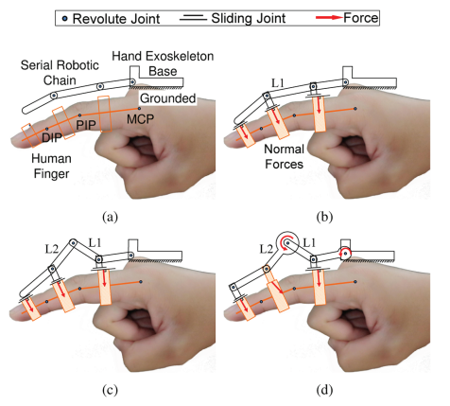

**Fig. 2.** Kinematic schematic of various chains in the hand exoskeleton system. (a) Kinematic chains in the system, (b) sliding joints connecting the finger and the exoskeleton kinematic chain, (c) DOF analysis of the three closed loops in the coupled system, and (d) actuated mechanism schematic. The proximal, middle, and distal chains are referred to as MCP, PIP, and DIP chains, respectively.

**Experimental Setup and Analysis:**

The experimental setup of the study includes a series of tests to evaluate the performance and efficacy of the developed index finger exoskeleton. These tests encompass torque tracking analysis, kinematic transparency assessments, validation of joint torque tracking, and dynamic transparency evaluations. Through these experiments, the researchers aim to demonstrate the device's ability to preserve natural finger motion, achieve precise torque control, and offer minimal resistance to finger movement. The analysis of experimental results provides insights into the device's functionality and its potential for effective hand rehabilitation.

**Conclusion and Limitations:**

The paper presents a significant advancement in the field of rehabilitation robotics through the development of an innovative index finger exoskeleton with series elastic actuation. The study showcases the device's capability to provide accurate force and torque control, essential for aiding individuals with upper extremity disabilities in regaining hand functionality and independence in daily activities. However, the study acknowledges certain limitations, such as the need for further validation in clinical settings and the potential for improvements in controller algorithms to enhance user-device interaction. Despite these limitations, the research sets a solid foundation for future advancements in hand exoskeleton technology, emphasizing the importance of precision, safety, and user comfort in rehabilitation robotics.